Web-Based Employee Attendance and Digital Inventory System: Case Study at PT. JTL Logistik Nawasena Indonesia
Nabilah Nur Zakiyyah ^{a,1}, Suryaningrat ^{b,2}
^{ab} Pamulang University,Jl. Raya Puspitek, Pamulang District, South Tangerang City, Banten 15310, Indonesia
¹ nabilahnurzkiyyah@gmail.com; ² d02362@unpam.ac.id
Contact number: +6285890069218
ARTICLE INFO | ABSTRACT
Article history:  Received  Revised  Accepted | Human resource management and supporting operations that are still carried out manually have the potential to cause delays in information, low data accuracy, and suboptimal administrative oversight. This study aims to design and implement a web-based HR Management System capable of integrating authentication, attendance tracking, leave and permission requests, report monitoring, employee management, and inventory management into a single centralized system. The system was developed using Laravel 10, Blade Templates, JavaScript, and MySQL with a Model-View-Controller (MVC) architectural approach. The attendance feature utilizes a camera, GPS, and MediaPipe Face Detection to support attendance validation, while leave management is carried out through a request-and-approval mechanism based on user roles. The results of the implementation show that the system is capable of supporting more structured data recording, streamlining administrative processes, improving monitoring efficiency, and strengthening access control through user role assignment and the implementation of system security mechanisms.  Copyright © 2026 by the Authors.
Keywords:
Face Detection
GPS Tracking
HR Management System
Inventory Management
Web-Based Application

Introduction
Advances in information technology are driving organizations to implement digital systems to support the effective management of human resources and internal operational processes. In practice, activities such as attendance tracking, leave and permission requests, employee data management, and inventory tracking are often still carried out separately, leading to inefficiencies, duplication of work, and delays in information dissemination. The use of information systems is crucial to replace conventional methods and accelerate administrative services(Ichsan et al., 2023) The HR Management System at PT. JTL Logistik Nawasena Indonesia was developed as a web-based application to integrate HR administration and supporting operations. Developing a web-based application is the right choice to simplify administrative work and manage reports efficiently(Agus Heri Yunial, 2024). Previous studies have shown that the Laravel framework provides a structured development environment with built-in features that improve development efficiency and simplify the implementation of web-based information systems (Surahmat & Darmawan, n.d.)The system provides modules for authentication, clock-in and clock-out, leave and time-off requests, approval by the superadmin, attendance report monitoring, employee data management, profile management, and warehouse inventory. Additionally, the system implements access rights divided into three main roles superadmin, PIC, and employee ensuring that each user has access to functions aligned with their duties and authority.
One of the key components of this system is the digital attendance module, which utilizes cameras, facial recognition, GPS, and automatic recording of time and location. A web-based employee attendance application can improve attendance recording efficiency and reduce data loss(Roosdianto et al., 2021) This implementation is intended to improve the validity of attendance data, reduce the potential for attendance manipulation, and simplify the verification process for management. In addition, the system is supported by a statistics dashboard, inventory management based on physical inventory counts and stock transfers, as well as security measures such as rate limiting, input validation, authorization middleware, and user session management. Based on this description, the development of this HR Management System aims to produce a system capable of improving administrative efficiency, data recording accuracy, and the effectiveness of monitoring in the company’s HR and operational functions. With this integrated system, the organization is expected to manage data and make decisions more quickly, accurately, in a controlled manner.

Method

Approaches and System Types
This study employs a web-based information system development approach to build an HR Management System capable of integrating human resource administration and supporting operational functions into a single platform. The developed system includes modules for authentication, attendance tracking, leave and permission requests, approvals, report monitoring, employee management, warehouse inventory, and user profile management. This approach was chosen because the system requirements indicated the need to handle several work processes in a structured, fast, and centralized manner through a web-based application.

Architecture System
The system architecture used is Laravel’s built-in Model-View-Controller (MVC) architecture. In this architecture, the model is used to represent database tables via the Eloquent ORM, the view is used to build the user interface with Blade Templates, while the controller handles business logic, validation, and request processing flow. The use of Laravel as the framework supports a structured development process for web-based management information systems(Dika Andreano Vega et al., n.d.) Based on the files, the application structure consists of the app/Models, Http/Controllers, Http/Middleware, resources/views, and routes/web.php folders, making the system development process more organized and easier to maintain.

Functional System Design
The functional design of the system was carried out by dividing the application into main modules according to user needs. The authentication module is used for login, logout, forgotten password, and password reset; the attendance module is used for recording arrival and departure times based on camera and GPS data; the leave and permission module is used for requests and approvals; while the inventory module is used for adding items, conducting stock takings, transferring stock, and generating reports. In addition, the system divides access rights into three roles superadmin, PIC, and employee so that each user can only access features corresponding to their responsibilities.
The functional design of the system was carried out by dividing the application into several main modules to meet user requirements. Android-based GPS technology has also been used in attendance information systems to support location verification in real time(Budiman et al., 2022) The complete list of the modules developed in this HR Management System is presented in Table 1.

Table 1. Main modules of the HR Management System

Modules | Description
Authentication | Login, logout, forgot password, and reset password (with rate-limiting).
Attendance (Face Detection) | Clock-in and clock-out using a camera, face detection, and GPS tracking.
Leave & Time-off Requests | Employees can submit leave or time-off requests, including supporting document uploads.
Leave/Time-off Approval | Superadmin approves or rejects employee requests.
Attendance Monitoring & Reports | Daily and monthly summaries, as well as tardiness history.
Employee Management | Employee data CRUD (Create, Read, Update, Delete) operations managed by the Superadmin.
Inventory (Warehouse) | Stock taking, adding new items, stock transfers, and reporting.
Profile | Profile editing and password change management for each user.

Data and Database Management
The system uses MySQL as its primary database, running via XAMPP with the database named “hr-management.” Data access is handled using the Eloquent ORM, so interactions with tables are performed through models such as User, Attendance, Leave, LeaveType, Inventory, Stock Opname, and Transfer Stock, without using raw SQL directly. The file also explains that the database is designed through table migrations and relationships between models for example, the relationship between users and their attendance data and leave requests ensuring that data management is more consistent and structured.

Implementation of Face Recognition and GPS-Based Attendance System
The implementation of the system’s core processes includes authentication, attendance, leave requests, inventory, and a statistics dashboard. In the authentication module, the system uses `Auth::attempt()`, enforces rate limiting of a maximum of five failed attempts per email-IP combination, disables self-registration, and redirects users to different pages based on their role after login. In the attendance module, the system uses a stateful session mechanism that checks the last record on the same day to prevent double check-ins and prevent check-outs without a prior check-in. During the attendance process, a photo is sent from the frontend in Base64 format, then decoded and saved as a .jpg file, while GPS data including latitude, longitude, and address is sent simultaneously from the browser. The file also explains that the system utilizes MediaPipe Face Detection to detect the presence of a face when the user takes a photo, so the attendance process can only continue if a face is detected. MediaPipe Face Detection provides a lightweight and real-time machine learning pipeline for detecting human faces across various devices, making it suitable for web-based attendance systems that require fast and efficient face verification(Lugaresi et al., 2019) After the photo is successfully captured, the system adds a watermark with the date, time, and attendance type, then sets a 30-second submission time limit to ensure the capture process remains real-time. Face recognition technology can be used to verify employee presence and strengthen attendance validation (Ilham et al., n.d.)
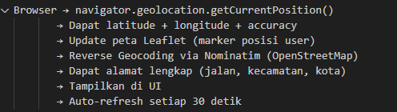
Figure 1 End-to-end GPS and Maps flow
In the leave and time-off module, the system categorizes requests based on the “type” field specifically, “leave” and “time-off” and retrieves the specific type from the `leave_types` table. Each request is saved with a “pending” status, requires superadmin approval, allows for the attachment of supporting documents, and uses database transactions to maintain data consistency during the saving process. In the inventory module, the system grants special authorization to the “pic” role, supports the stock-taking process with stock variance calculations, and facilitates stock transfers between warehouses with inventory availability validation.
The system dashboard is also designed differently for each user role. The employee dashboard displays statistics on attendance, tardiness, leave, and holidays; the PIC dashboard displays inventory and warehouse activity statistics; while the superadmin dashboard displays the total number of employees, today’s attendance figures, and the number of employees currently on leave. With this breakdown, the system can present relevant information tailored to each user’s needs.
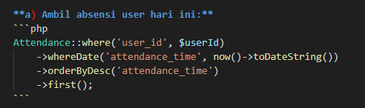
Figure 2 Code snippet for the attendance feature
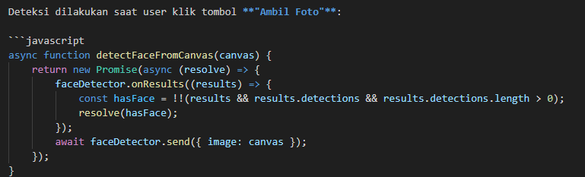
Figure 3 JavaScript logic for the "Take Photo" action.

System Security
System security is implemented through several mechanisms mentioned in the file. These mechanisms include CSRF protection on every POST form, password hashing using `Hash::make()`, password strength validation, auth and guest middleware, input validation on every request, session regeneration after login, session invalidation upon logout, and clearing `sessionStorage` when a user switch occurs on the frontend. In addition, the system also implements role-based authorization and rate limiting during the login process to reduce the risk of access abuse and brute-force attacks.

Results and Discussion
The results obtained using the proposed system are discussed in this section.

Authentication Interface
The login page interface is used by all roles (Superadmin, PIC, and Employees) to enter the system. It uses Auth::attempt() and enforces rate-limiting to prevent brute-force attacks by locking the account for 60 seconds after five failed attempts.
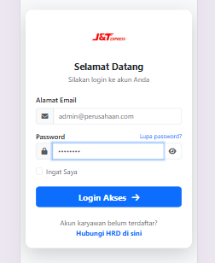
Figure 4 System login interface

Employee Attendance Interface
The employee dashboard focuses on the attendance feature The attendance module is designed to support real-time reporting and automated processing of user attendance data(1971-File Utama Naskah-11670-1-10-20260622, n.d.). A web-based attendance system using GPS can improve attendance accuracy and reduce manual recording (Purwanto et al., 2024).The system utilizes MediaPipe Face Detection to verify the user's face and captures the GPS coordinates (latitude and longitude). A 30-second countdown timer is implemented to ensure real-time capture.
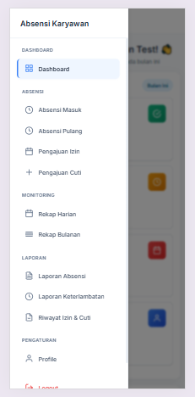
Figure 5 Employee attendance interface with face detection and GPS

PIC Inventory Management Interface
Users with the PIC role have special authorization to access the warehouse inventory module. This interface allows the PIC to manage stock items, conduct stock-taking (calculating the variance between recorded and physical stock), and perform stock transfers between locations.
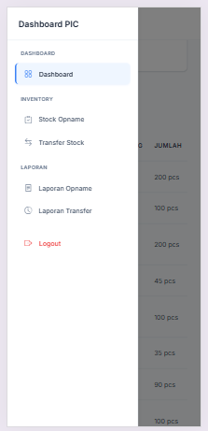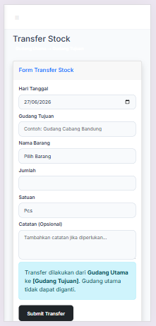
Figure 6 Inventory sidebar & Transfer Stock

Superadmin Dashboard Interface
The superadmin has full access to the system. The superadmin dashboard displays comprehensive statistics, including the total number of employees, the number of employees present today, and the number of active leave requests. This centralized view aids management in monitoring daily operations. Web-based attendance systems have been implemented for educational institutions to simplify attendance management and reporting (Istiqomah Istiqomah et al., 2024)
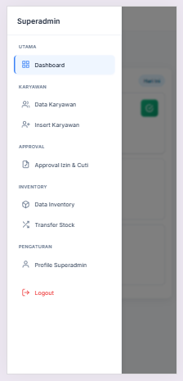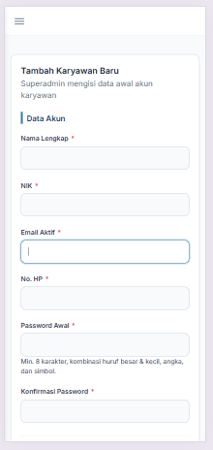
Figure 7 Superadmin sidebar & insert employee menu

References
1971-File Utama Naskah-11670-1-10-20260622. (n.d.).
Agus Heri Yunial. (2024). Waterfall Method In Designing A Web-Based Waste Payment Information System (Case Study: Calincing Bukit Valley Housing Rt04/Rw008). Jurnal Inotera, 9(1), 226–232. https://doi.org/10.31572/inotera.vol9.iss1.2024.id336
Budiman, A., Fabian, Yaputera, R. A., Achmad, S., & Kurniawan, A. (2022). Student attendance with face recognition (LBPH or CNN): Systematic literature review. Procedia Computer Science, 216, 31–38. https://doi.org/10.1016/j.procs.2022.12.108
Dika Andreano Vega, L., Julio Pratama, A., & Hermawan, L. (n.d.). 4 TH MDP STUDENT CONFERENCE (MSC) 2025 Universitas Multi Data Palembang | 306 Pengembangan Management Information System Berbasis Laravel untuk Optimasi Produktivitas Karyawan PT.XYZ.
Ichsan, Feri Susilawati, & Muhammad Haykal. (2023). Design and Build a Web-Based Village Information System for Acceleration of Village Services in Gampong Jantho Makmur. Jurnal Inotera, 8(1), 155–161. https://doi.org/10.31572/inotera.vol8.iss1.2023.id233
Ilham, F., Parvez Bahiyuddin, M., & Saputra, S. W. (n.d.). Perancangan Sistem Absensi Terintegrasi GPS dan Verifikasi Foto Berbasis Web untuk Monitoring Efisiensi Kerja Karyawan PT Pintar Inovasi Mandiri.
Istiqomah Istiqomah, Priti Rindi Artika, M. Fakhriza, & Pitta Emma Sitorus. (2024). Sistem Informasi Absensi Siswa Berbasis Web di SMKS Teladan Pematangsiantar. Jurnal Ilmiah Sistem Informasi Dan Ilmu Komputer, 4(1), 65–77. https://doi.org/10.55606/juisik.v4i1.743
Lugaresi, C., Tang, J., Nash, H., McClanahan, C., Uboweja, E., Hays, M., Zhang, F., Chang, C.-L., Yong, M. G., Lee, J., Chang, W.-T., Hua, W., Georg, M., & Grundmann, M. (2019). MediaPipe: A Framework for Building Perception Pipelines. http://arxiv.org/abs/1906.08172
Purwanto, D., Putri, R. E., Fadly, Y., & Pratiwi, D. C. (2024). Sistem Absensi Online Berbasis Web Dengan Penggunaan Teknologi GPS. Jurnal Minfo Polgan, 13(2), 1800–1811. https://doi.org/10.33395/jmp.v13i2.14258
Roosdianto, R., Sari, A. O., & Satriansyah, A. (2021). RANCANG BANGUN APLIKASI SISTEM INFORMASI ABSENSI KARYAWAN ONLINE. INTI Nusa Mandiri, 15(2), 135–142. https://doi.org/10.33480/inti.v15i2.1932
Surahmat, A., & Darmawan, R. (n.d.). Application of SDLC Method and Laravel Framework in the Development of Web-Based Company Profile Information Systems.

